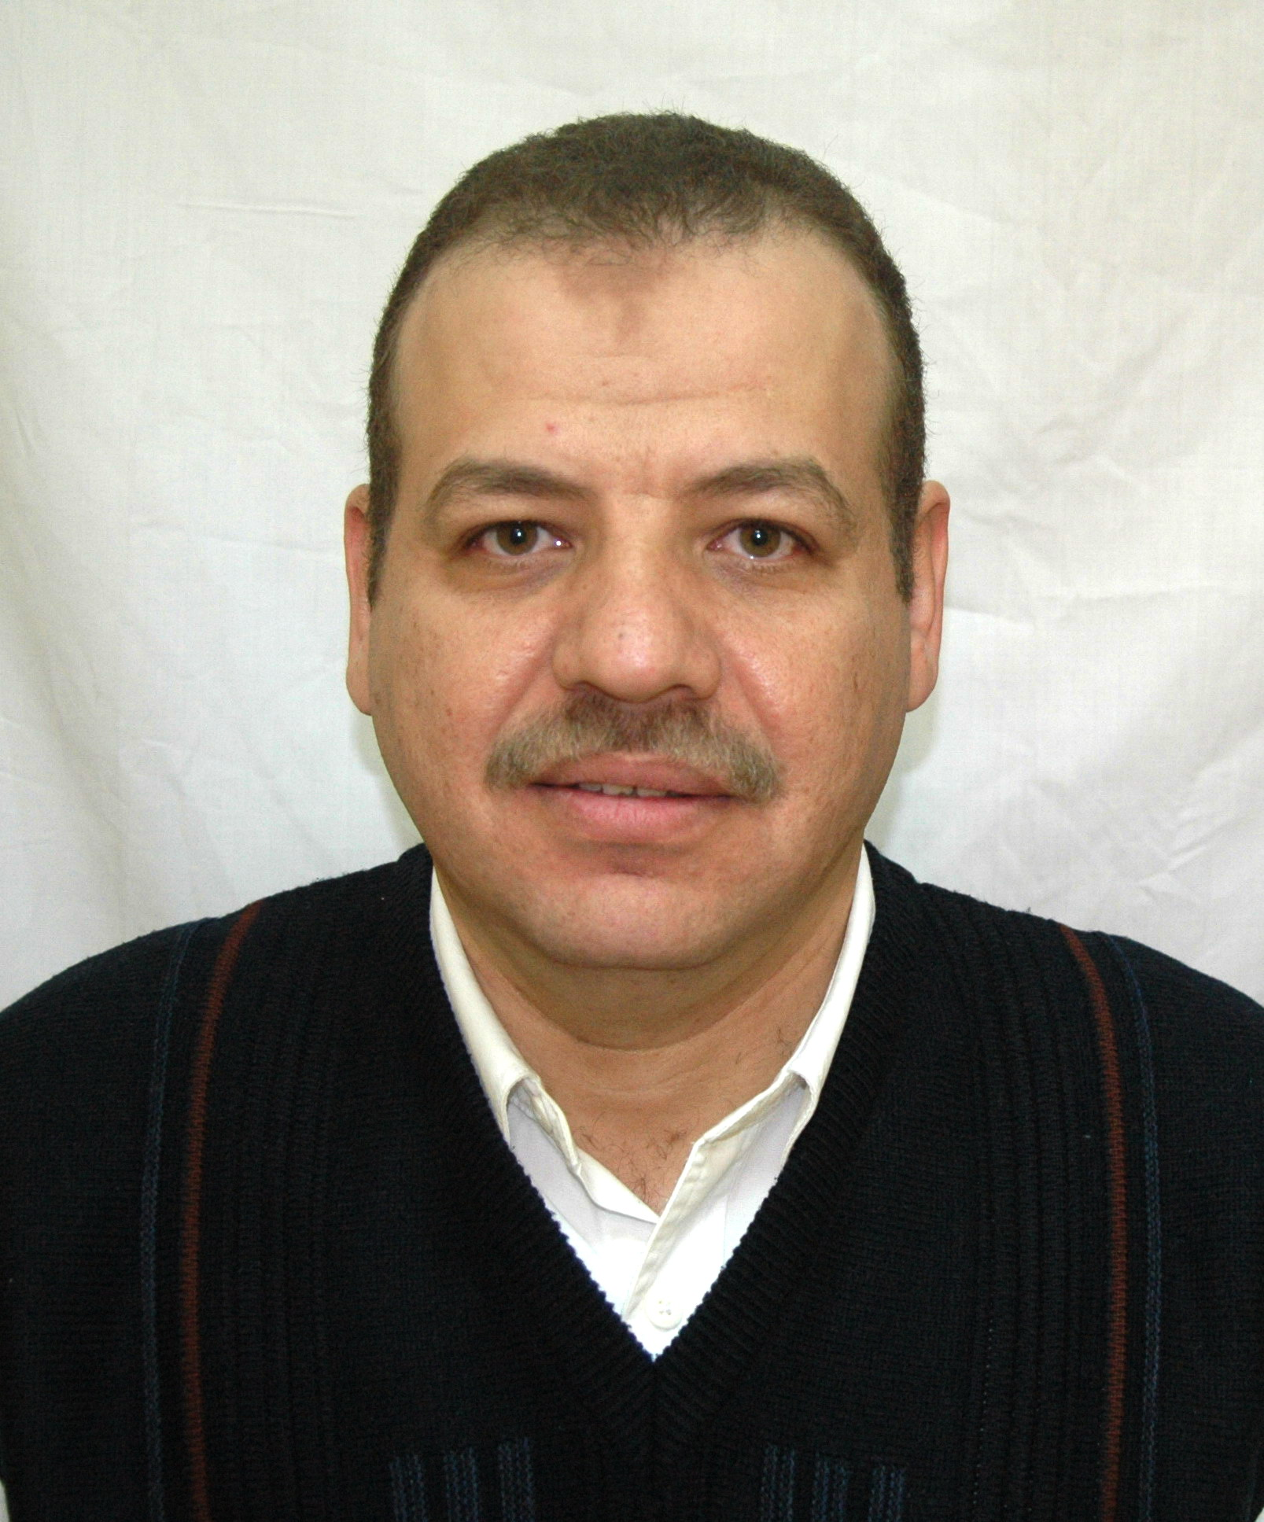 | ASSUIT UNIVERSITY  FACULTY OF SCIENCE  PHYSICS DEPARTMENT  EGYPT | 

CERRICULUM VITAE

NAME

Date of Birth: Mohammed Abu El-Oyoun Hassan Hussein
Citizenship:
Address: Physics Department – Faculty of science – Assiut University – Assiut – Egypt
Phone: +201099621708
Fax: +2 0882342223
Email: oyoun@aun.edu.eg
Website:
http://www.aun.edu.eg/membercv.php?M_ID=351
google scholar:
https://scholar.google.ca/citations?hl=en&imq=Mohamed+Abu+El-Oyoun&user=uKCzRKUAAAA
Martial status: Married
Current position: Professor

EDUCATION

YEAR DEGREE UNIVERSITY/COUNTRY

1. October 1998 Ph.D. (Physics) Assiut/Egypt
2. February 1994 M.Sc. (Physics) Assiut/Egypt
3. July 1989 B.Sc. (Physics) Assiut/Egypt

AWARDS AND SCHOLARSHIPS

YEAR AWARD/SCHOLARSHIP UNIVERSITY/COUNTRY

1. 2000 Postdoctoral Kanazawa/Japan

EMPLOYMENT

YEAR POSITION UNIVERSITY/COUNTRY

1. 2013 Professor Assiut/Egypt
2. 2004 Associated Professor Assiut/Egypt
3. 1998 Lecturer Assiut/Egypt
4. 1994 Assistant lecturer Assiut/Egypt
5. 1989 Demonstrator Assiut/Egypt

VISITOR AND TRAINING APPOINTEMENTS

YEAR POSITION UNIVERSITY/COUNTRY

1. 2000 Researcher Kanazawa/Japan

========================================================
TEACHING EXPERIENCE AND STUDENTS SUPERVISION

YEAR POSITION UNIVERSITY/COUNTRY

1. 1998-1999 Lecturer Assiut/Egypt
2. 1999-2000 Lecturer Assiut/Egypt
3. 2002-2003 Lecturer Assiut/Egypt
4. 2003-2004 Lecturer Assiut/Egypt
5. 2004-2005 Lecturer Assiut/Egypt
6. 2005-2006 Associate Professor Assiut/Egypt
6. 20013- Professor Assiut/Egypt

Course Number | Course Name | Under-graduate | Graduate | Postgraduate | No. of Semesters
PHYS | General Phys. | √ |  |  | 8
PHYS | Modern Phys. | √ |  |  | 8
PHYS | Physical Optics | √ |  |  | 6
PHYS | Low Temp. Phys. |  | √ |  | 2
PHYS | Introduction of semiconductor |  | √ |  | 2
PHYS | Exp. Thermal Analysis |  |  | √ | 3

Students Supervision:
YEAR DEGREE UNIVERSITY/COUNTRY

1. 2000 M.Sc. Assiut/Egypt
2. 2002 M.Sc. Assiut/Egypt
3. 2005 M.Sc. Assiut/Egypt

========================================================
RESRAECH INTRESTS
Structure Properties of Amorphous Materials, Thermal analysis and Computer programmer.

CONFERENCES AND PRESENTATIONS

1. “62nd Autumn Technical Meeting of the Japan Society of Applied Physics”, which was held in Aichi Institute of Technology, Aichi, Japan, September 11-14, 2001
2. Applied Physics Hokuriku Shin' etsu Branch which was held in Nagaoka University of Technology on December 8&9, 2001
3. “49th Spring Technical Meeting of the Japan Society of Applied Physics and Related Society”, which was held in Tokai University, Hiratuka, Tokyo, Japan, March 27-30, 2002.
4. Fourth Saudi Science Conference Contribution of Science Faculties In the Development Process of KSA, Taibah University, El-Madenah El-Munawarah, KSA, March 21-24/3/2010.

